**SE185: Problem Solving in Software Engineering**

**Quiz # 8 (100 points)**

|  |  |
| --- | --- |
| Name: Camden Fergen | Name: Jun-sang Kim |

Answer the following questions and make a pdf file that includes the **source code, sample inputs, and outputs**. You must submit the **pdf file and all of the .c files** on Canvas for full credit. Do not forget to add your group partner name on the pdf file and the source codes.

1. **(50 points)** Write a complete c program which calculates the addition, subtraction, and multiplication of two complex numbers (given by user) using structures to the function and then print the results.

**Inputs and outputs format:**

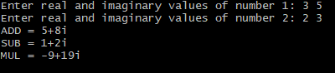

1. **(50 points)** Without altering the program structure, complete the following program that will ask user to enter total seconds. Then the program converts those seconds to hours, minutes, and remaining seconds (e.g., 3665 sec = 1 hr 1 min 5 sec) by calling a function (void convTime) and **store the information** as a subitems (members) in a **time variable (struct)**. Finally, the program prints the output by calling another function (void printTime) and the output must follow the format shown below:

|  |
| --- |
| /*add header file*/  typedef struct time {     int hr;     int min;     int sec; } time; /*declare functions*/ void main() {     time *mileTime;  /*allocate memory*/  int seconds;   printf("Total seconds: ");  scanf("%d", &seconds);  convTime(/*pass parameters*/);      printTime(/*pass parameters*/); }  void convTime(/*pass parameters*/) { /*function definition*/  } void printTime(/*pass parameters*/) { /*function definition*/ } |

**Inputs and outputs format:**



# Problem 1

Code:

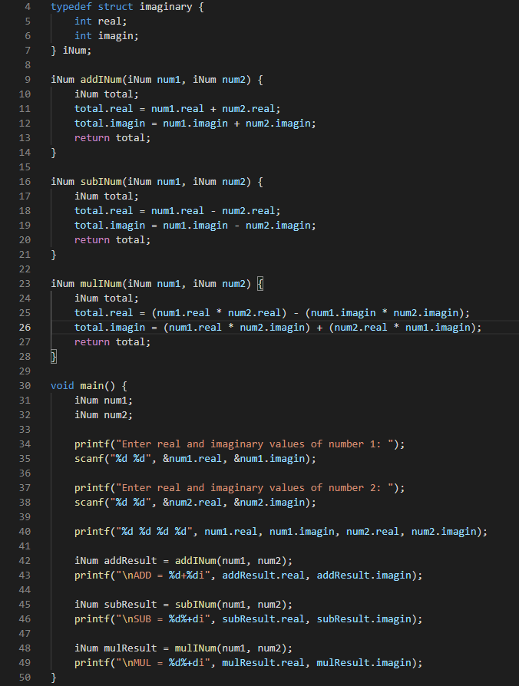

Output:

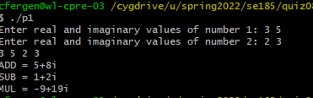

# Problem 2

Code:

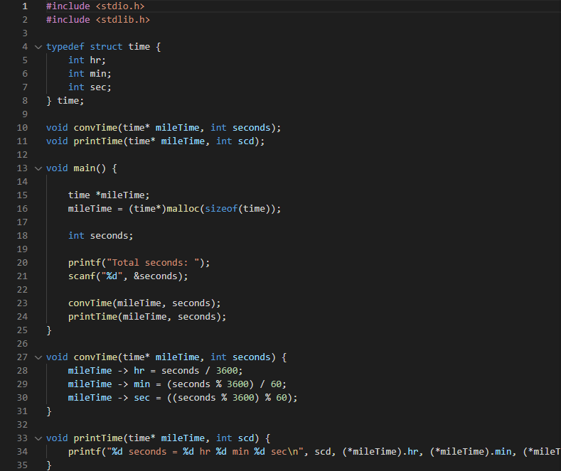

Output:

